**Homework 2**

**DCT Transforms**

The objective of this assignment is to understand and implement the concept of Discrete Cosine Transform (DCT) and to strengthen your knowledge of JPEG image compression techniques.

You are required to apply the Discrete Cosine Transform to grayscale images and implement it in Python, you can use opencv’s DCT function or numpy‘s fft function, or you can design an algorithm according to the formula below and documenting all your observations in the report.

In addition, in this assignment, we hope you can do simple filtering in the frequency domain. We know that after DCT conversion, the energy will be concentrated in the upper left corner. Please crop this area (the size is arbitrary) and observe the results after returning through I2DCT.

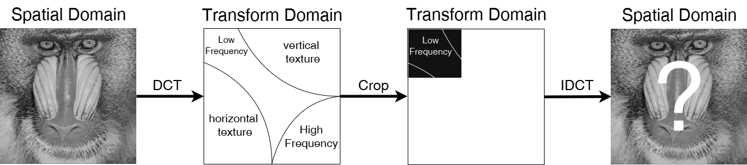

It was mentioned in class that DCT can be decomposed into Fast DCT, and if you manage to implement this, you will receive a higher score.

Bonus: We encourage you to use other techniques mentioned in class to complete the image compression (e.g., vector quantization, Huffman coding, Discrete Wavelet Transform (DWT), and complete JPEG encoding and decoding). If you mention these techniques in your report and include your implementation results, you will be awarded a higher score.

The report must contain the following(Submit the PDF)：  
1. Screenshots：Original image, DCT image in frequency domain, image after inverse DCT processing, image after frequency domain filtering and inverse DCT

2. Explain：Your method (if you have other try) with experiment

3. Discussion：interesting finding, difficulties you encountered, insights you observe